Data Preprocessing:

Data Cleaning:
The dataset was cleaned by filling missing values using forward fill and backward fill methods, and then dropping any remaining missing values.
Feature Scaling:
StandardScaler was used to scale the features for models like SVM and k-NN.
Class Imbalance Handling:
ADASYN was used to handle class imbalance by oversampling the minority class.

APPROACH :

The Dynamic Classifier Selection approach employs a variance-based strategy to select the most suitable classifier for each sample in the testing set. This approach recognizes that different classifiers excel in different regions of the feature space, and by dynamically selecting the best classifier for each sample.
The dynamic classifier function select_classifier_based_on_variance, takesthe calculated variance as input and selects the appropriate classifier based on the following rules:
- Low Variance Samples (< 0.5): Balanced Random Forest is selected for samples with low variance, as it is well-suited for handling datasets with minimal variability.
- Medium Variance Samples (0.5 ≤ variance < 1.5): k-Nearest Neighbors (k-NN) is chosen for samples with medium variance, as it is effective in handling datasets with moderate levels of variability.
- High Variance Samples (≥ 1.5): Isolation Forest is selected for samples with high variance, as it is designed to handle datasets with significant variability and outliers.

Different Models Tried On The Approach :
Model | TPR (Recall) | FPR | TNR (Specificity) | FNR | Accuracy | ROC AUC
RandomForestClassifier | 0.9257 | 0.1042 | 0.8958 | 0.0743 | 0.91 | 0.967859321031007
KNN | 0.70 | 0.39 | 0.61 | 0.30 | 0.66 | 0.709959520059276
Gradient Boosting | 0.88 | 0.11 | 0.89 | 0.12 | 0.88 | :0.954510335150877
SVM | 0.5977 | 0.5685 | 0.4315 | 0.4000 | 0.5149863
SMOTE+Dynamic Classifier+Hyperparameter Tuning | 0.90 | 0.95 | 0.05 | 0.10 | 0.47
Dynamic Classifier + Thresholds | 0.997 | 0.7527 | 0.2473 | 0.0067 | 0.62 | 0.698
Dynamic Classifier +Fixed Threshold | 0.924 | 0.369 | 0.369 | 0.076 | 0.65
Ensemble Results | 0.7685 | 0.1085 | 0.8915 |  | 0.87
Dynamic Classifier(RF,Boosting,SVM,Isolation Forest) | 0.8755 | 0.0860 | 0.9140 | 0.1245 | 0.89 | 0.9092
Dynamic Classifier(RF,KNN,SVM,Isolation Forest) | 0.8770 | 0.0857 | 0.9130 | 0.1217 | 0.90 | 0.90

2nd table for our own comparison :

Model | TPR (Recall) | FPR | TNR (Specificity) | FNR | Accuracy | ROC AUC
Ensemble(LR, RF, SVM, GB) Soft voting | 0.8615 | 0.1410 | 0.8790 | 0.1385 | 0.8682 | 0.94
Ensemble(XGB, RF, SVM, GB) Soft voting | 0.9575 | 0.0923 | 0.9077 | 0.0425 | 0.9316 | 0.97
Dynamic Classifier(RF,Boosting,SVM,Isolation Forest) | 0.8755 | 0.0860 | 0.9140 | 0.1245 | 0.89 | 0.9092
Dynamic Classifier(RF,KNN,SVM,Isolation Forest) | 0.8770 | 0.0857 | 0.9130 | 0.1217 | 0.90 | 0.90
Stacking (RF, GB, BRF) + XGBoost Meta-Learner | 0.9333 | 0.0592 | 0.9408 | 0.0667 | 0.937 | 0.9791
Stacking (RF, GB, BRF ) + LogisticRegression Meta-Learner | 0.9452 | 0.0586 | 0.9414 | 0.0548 | 0.9433 | 0.9841
Stacking (RF, GB, XGB) + LogisticRegression Meta-Learner | 0.9486 | 0.0569 | 0.9431 | 0.0514 | 0.9459 | 0.9867
Optimized XGBoost-PSO technique | 0.96 | 0.0858 | 0.9142 | 0.0799 | 0.96 | 0.96
BiLSTM-LogitBoost | 0.9241 | 0.0368 | 0.9632 | 0.0759 | 0.8945 | -

Model Performance:
The Dynamic Classifier Selection approach demonstrates promising results in detecting electricity theft. The model's ability to adapt to varying levels of variance in the data allows it to effectively handle complex patterns and relationships. The use of multiple classifiers and dynamic selection enables the model to leverage the strengths of each algorithm, leading to improved overall performance.

Why This Method Is Best:
This method is best because it:
- Handles class imbalance: ADASYN oversamples the minority class, reducing the impact of class imbalance.
- Selects the best classifier: Dynamic classifier selection based on variance chooses the most suitable model for each sample, improving overall performance.
- Combines strengths: The method leverages the strengths of multiple models (Random Forest, k-NN, and Isolation Forest) to improve accuracy and robustness.
Overall, this approach effectively addresses the challenges of class imbalance and model selection, leading to improved performance in electricity theft detection.

The dynamic classifier selection approach is used to:
- Handle varying data distributions: Different classifiers perform better on different types of data. By selecting the best classifier for each sample, you can adapt to changing data distributions.
- Improve performance: By choosing the most suitable classifier for each sample, you can improve overall performance and accuracy.
- Reduce overfitting: By using multiple classifiers and selecting the best one for each sample, you can reduce overfitting and improve model robustness.
In your case, the dynamic classifier selection is based on the variance of the features, which helps to:
- Identify complex patterns: Variance-based selection can identify complex patterns in the data that may not be captured by a single classifier.
- Select the best model: By analyzing the variance of the features, the approach can select the most suitable classifier for each sample, improving overall performance.
The dynamic classifier selection approach works well for you because:
- Diverse data: Your electricity theft detection dataset likely has diverse patterns and relationships, making it suitable for a dynamic classifier selection approach.
- Class imbalance: The approach helps to handle class imbalance by selecting the best classifier for each sample, which is particularly useful in your case where the minority class (theft) is likely to be underrepresented.
- Non-linear relationships: The use of multiple classifiers, including RandomForest and k-NN, helps to capture non-linear relationships in the data, which is common in complex datasets like yours.
- Robustness to overfitting: The dynamic classifier selection approach reduces overfitting by using multiple classifiers and selecting the best one for each sample, which is particularly useful when working with complex datasets.

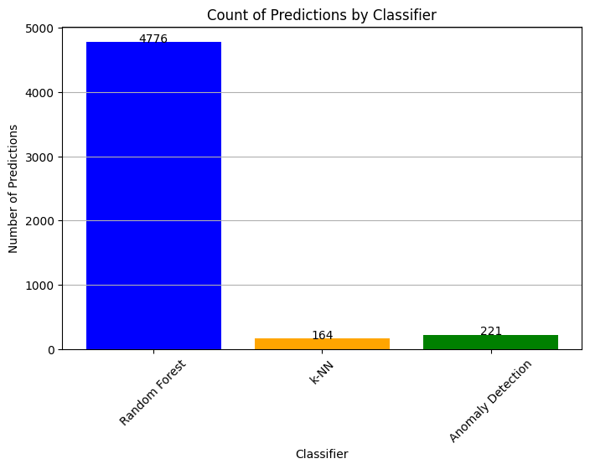

Total Samples: 5161
Predicted by Random Forest: 4776
Predicted by k-NN: 164
Predicted by Anomaly Detection: 221

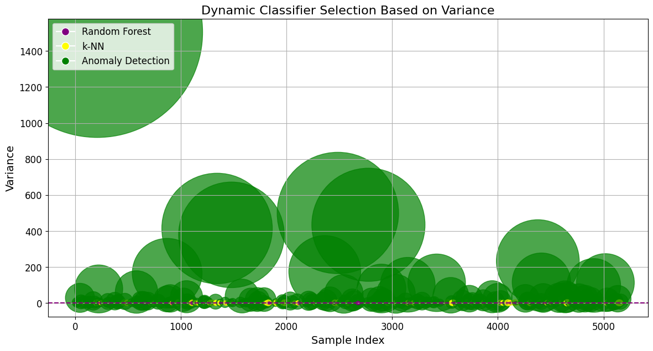

The image shows that the Anomaly Detection classifier (green circles) is able to identify areas of high variance in the data, which may indicate potential electricity theft. The k-NN and Random Forest classifiers (yellow and purple dots) are used to classify the data points into either "theft" or "non-theft" categories.

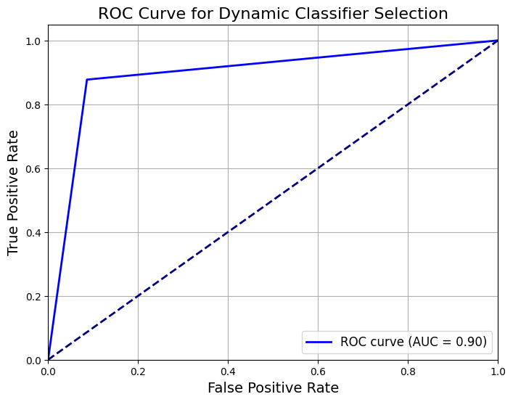

This ROC curve represents the performance of the Dynamic Classifier Selection model, which is used for electricity theft detection. The curve shows that the model is able to effectively distinguish between theft and non-theft cases, with a high true positive rate (correctly identifying theft cases) and a low false positive rate (incorrectly identifying non-theft cases as theft). The AUC value of 0.90 indicates that the model is performing very well, with a high degree of accuracy and reliability.

The classification report shows that the model achieves a balanced performance for both classes:
- Class 0.0 (Non-theft): The precision is 88%, meaning that 88% of the predictions for non-theft are correct. The recall is 91%, indicating that 91% of actual non-theft cases are correctly identified. The F1-score, which balances precision and recall, is 90%.
- Class 1.0 (Theft): The precision is 91%, so 91% of theft predictions are correct. The recall is 88%, indicating that 88% of actual theft cases are correctly identified. The F1-score is 89%.
- Overall Accuracy: The model's accuracy is 90%, meaning it correctly classifies 90% of all samples.

